**SOFTWARE ENGINEERING PROJECT**

Table of Contents

**1. Introduction3**

1.1 Project title3

1.2 Purpose of the document3

1.3 Background3

1.4 Project scope4

1.5 System purpose4

**2. Requirement analysis4**

2.1 Functional requirements4

2.2 Non-functional requirements5

2.3 Process model4

**3. Context Model6**

**4. Use Case Diagram7**

**5. Sequence diagram8**

# Introduction:

## Project title:

The title of our project is “**AH Psychoanalyst**”.

## Purpose of the document:

This is a Requirements Specification document for a web application that provides allocated resources for treating mental health disorders. This document describes the scope, objectives, and goals of the system. This document will model the functional requirements with use cases, interaction diagrams, and class models.

## Background:

AH psychoanalyst is for helping patients nationwide to find, book and consult doctors on their mental health problems. AH psychoanalyst customers include patients, clinics and doctors that are interested in treating the mental illnesses of people either by arranging therapy sessions remotely online or, if possible, for the doctor and the patient then face to face. The main purpose of our system is to help people treat the unsoundness of their mind online by booking sessions with the doctors on their own who think that it is a stigma to be called mental in the society, and they don’t realize how important it is to treat such an illness as it does not only harms them but also the people around them. On our website application, the patient can also take a quiz which is designed by psychologists in accordance with how the mind of a normal person works and based on these standards; it can help the patient determine their condition.

As the world becomes more globalized, internet use is becoming more widespread and accessible to everyone. So, to aid individuals, who are now only a click away from mental therapies, such a website application was created while keeping in mind current trends.

This innovative website brings therapy sessions not only for individuals but provides all kinds of therapies; whether you want to have a session as a family, couple, or teenager, you have all the options in one place. You can join support groups available on the website where the members (patients) of the group offer encouragement, support and comfort to other members by sharing their personal experiences and feelings, issues troubling them, coping strategies, or firsthand information about diseases or treatments. A chatbot is there to answer your questions and guide you, and an online pharmacy where you can buy your prescribed medicines in one place. The patient can leave reviews on our website to share their experience with others and help them. Our system provides a complaint system where the patient can complain about the therapists or treatments provided. We are using a more mainstream idea to help people deal with their psychological issues more easily without social pressure.

## Project Scope:

In Pakistan, mental diseases account for almost 4% of the overall disease burden, with women bearing a disproportionate share. The main purpose of making this web application is people don't believe that anything is wrong with them and therefore resist seeing a [psychiatrist](https://www.google.com/search?rlz=1C1CHBF_enPK1028PK1028&sxsrf=ALiCzsbe6kzB29fiRMAaxeYgtPbxviZBEA:1670001640237&q=why+people+resist+to+visit+a+psychiatrist&spell=1&sa=X&ved=2ahUKEwjpm6n0uNv7AhWGgv0HHSY5DXEQkeECKAB6BAgFEAE). They think that they will be called mentally retarded or something by the society. They may have an unconventional view of their reality that does not fit with traditional concepts of healing. This may cause them to reject conventional approaches. According to WHO data, Pakistan has 0.19 psychiatrists per 100,000 inhabitants, one of the lowest ratios in the WHO Eastern Mediterranean Region and the whole world. So, our web application helps such people to treat themselves remotely while sitting at home.

## System Purpose

Our system will provide the patients with customized browsing of the clinics and doctors, treatment types (kind of sessions the patient wants), and pharmacy to get the required medicines online. This will provide innovative marketing opportunities since the patients can find your clinic online, where most people look for information these days. People who are not your patients will be able to find your clinic with professional search engine optimization and a solid medical information database on our website application.

## Users

1. **Patients:**

These are the users who want to get help and therapy to resolve issues related to their mental health conditions

1. **Clinics/Doctors:**

These are the users who help treat the patients with mental illnesses

1. **System Administrator:**

The system administrator is responsible for sending response mails, monitoring the payment methods, online pharmacy, shipment, packaging, reviews, inventory and for answering the user’s questions and guiding them through the website

1. **Supplier:**

The supplier is responsible to restock the inventory when medicines are out of stock.

# Requirement Analysis:

## Functional requirements:

* A registration page must be provided to the clinics, doctors, and patients to register.
* Clinic's authenticity must be checked.
* Patient must register before getting the treatment.
* A verification email must be sent to the specified email address after registration.
* Patient can take a mini quiz to determine their condition.
* Patient who takes the quiz must be shown with the recommended doctors according to the results of the quiz.
* Patient must be provided with a menu page.
* Patient can search for doctors through the search engine.
* Patient can add filters to search.
* Patient should be asked if they want an online or face-to-face session.
* Patient should be able to select the type of consultation session they want, for example, if they want therapy as a family, couple, individual, etc.
* Patient can join online support groups for therapy.
* Patient will be provided with a chat box.
* Patients’ appointments and treatment histories should be stored in the database.
* Patients’ information can only be viewed by the patient themselves, the doctor/clinic treating the patient, and the system administrator.
* Confidentiality of the patient must be maintained.
* An online pharmacy for patients to buy prescribed medicines.
* Make prescription a must, to buy medicines.
* Only registered patients will have access to buy medicines from the online pharmacy.
* An online mode of payment for patients.
* The order would be sent for packaging
* It would be shipped to the provided address
* The receipt will be sent to the customers via email.
* The inventory would be monitored, and when it is low, it would be restocked by the supplier.
* Patients can leave reviews on the website to share their experiences to aid others.
* Website application should look good on a large computer monitor
* Website application should look good on a tablet or smartphone.
* Website application should be secure, so there are no data breaches.

## Non-Functional Requirements:

* The website application should be operational 24/7/365
* Easy navigation through web pages
* It should support multiple simultaneous users
* The transactions are to be transmitted in encrypted form.
* The system should be able to be upgraded without major reengineering.
* The website application should be viewable from different browsers.

## Process model:

This web application is based on the waterfall model. The most common software development technique is waterfall.  Its plan-driven methodology has been among the most widely used for projects involving web development for many years.

# The Context Model

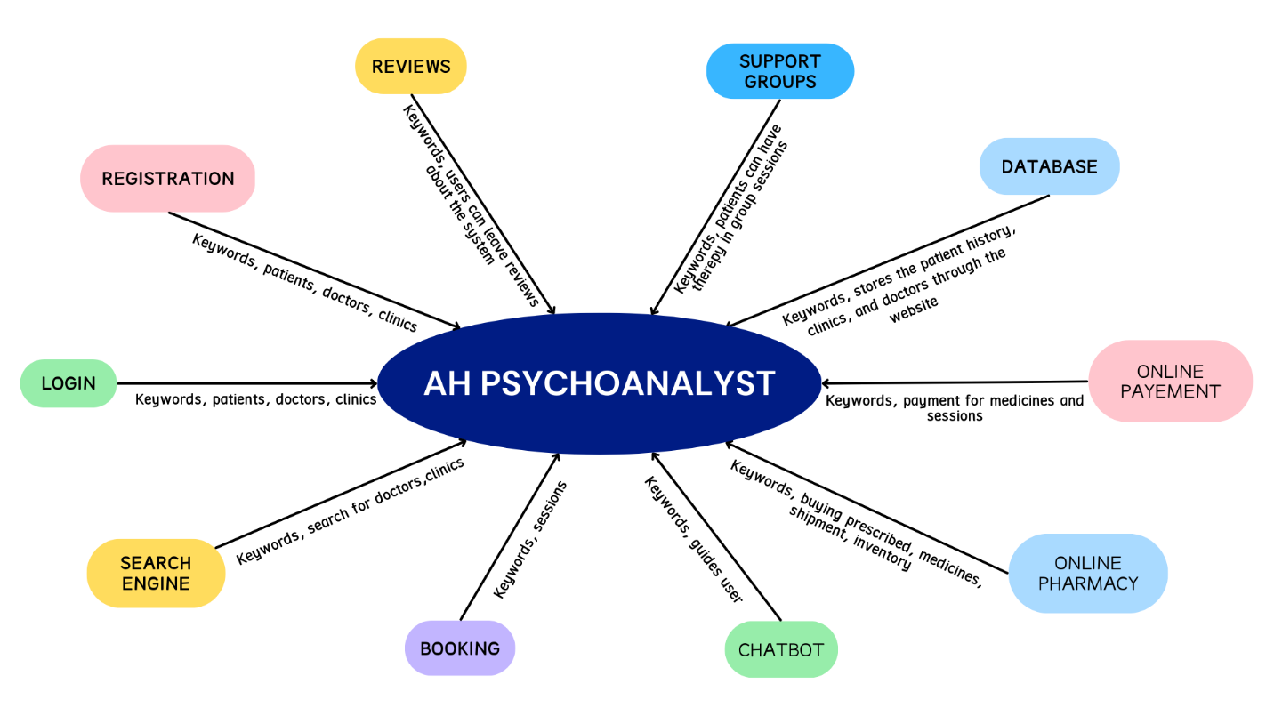

# The Use Case Diagram

# The Sequence Diagram

## 5.1: Registration

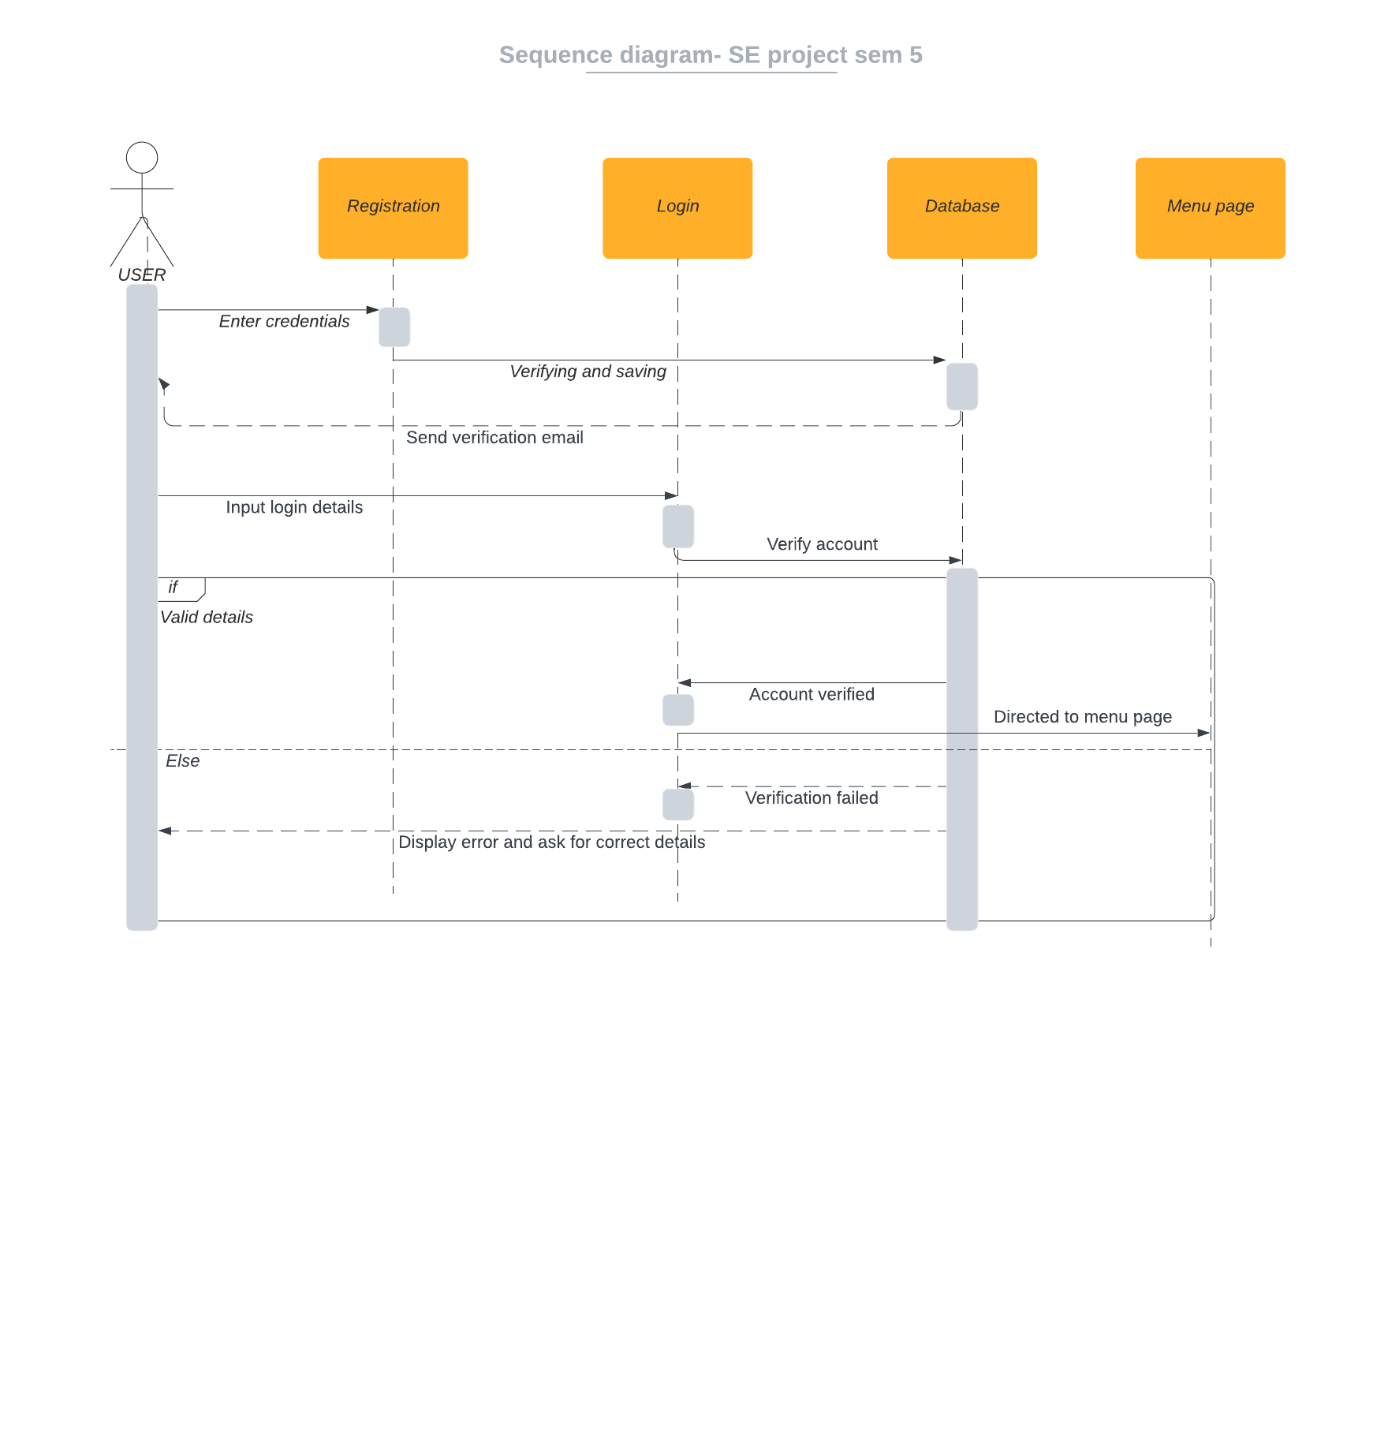

## Diagram Description automatically generated5.2: Mini Quiz and Search Engine

## 5.3: Booking an Appointment

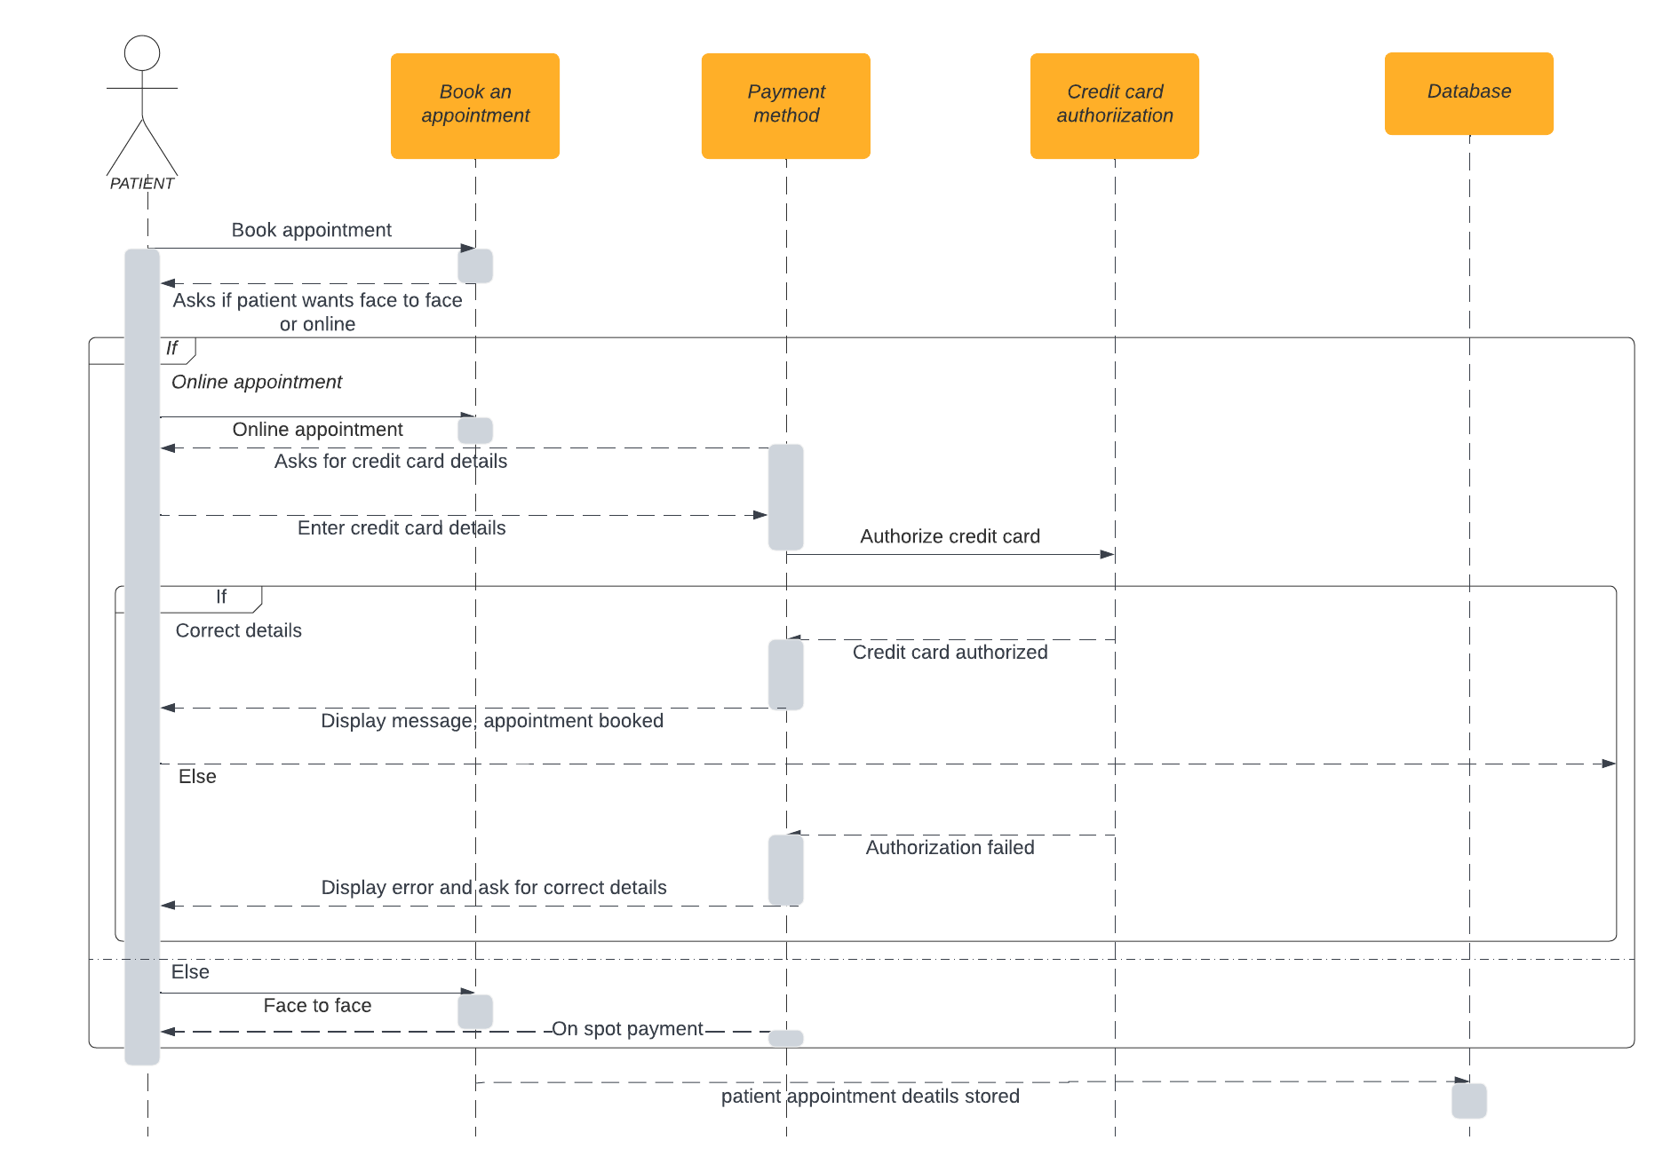

## 5.4: Buying Prescribed Medicines Online

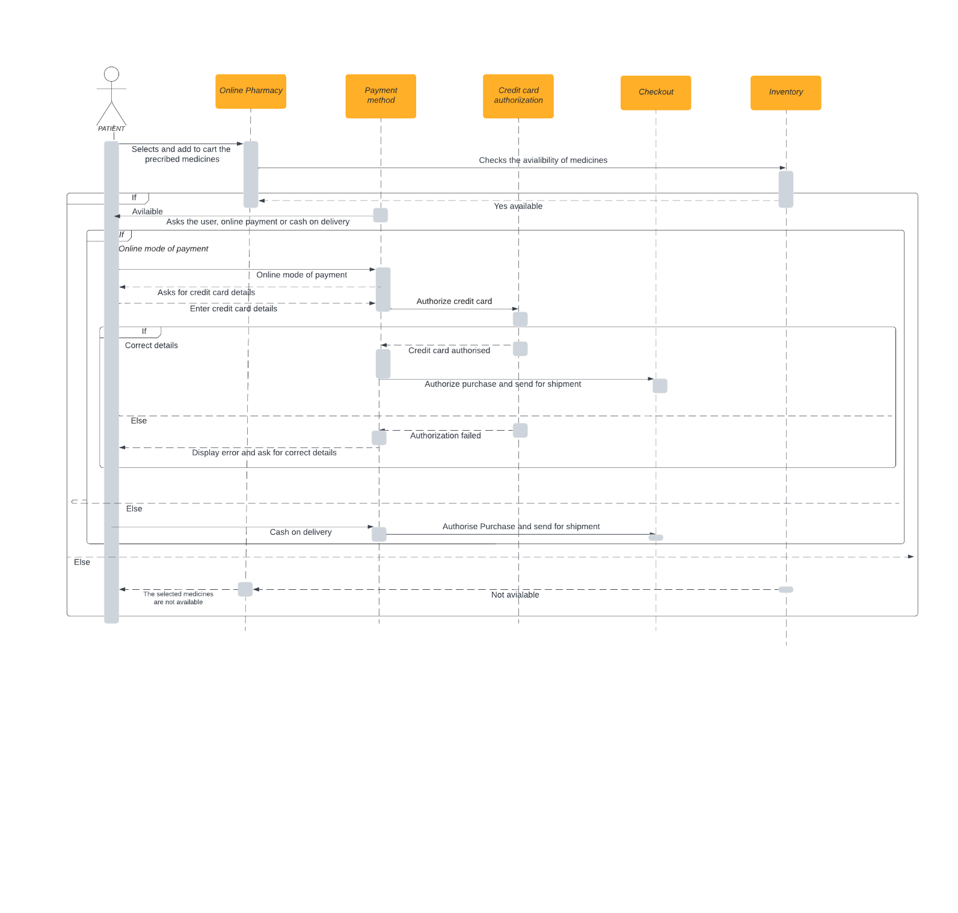

## 5.5: Join Support Group and Leave Reviews

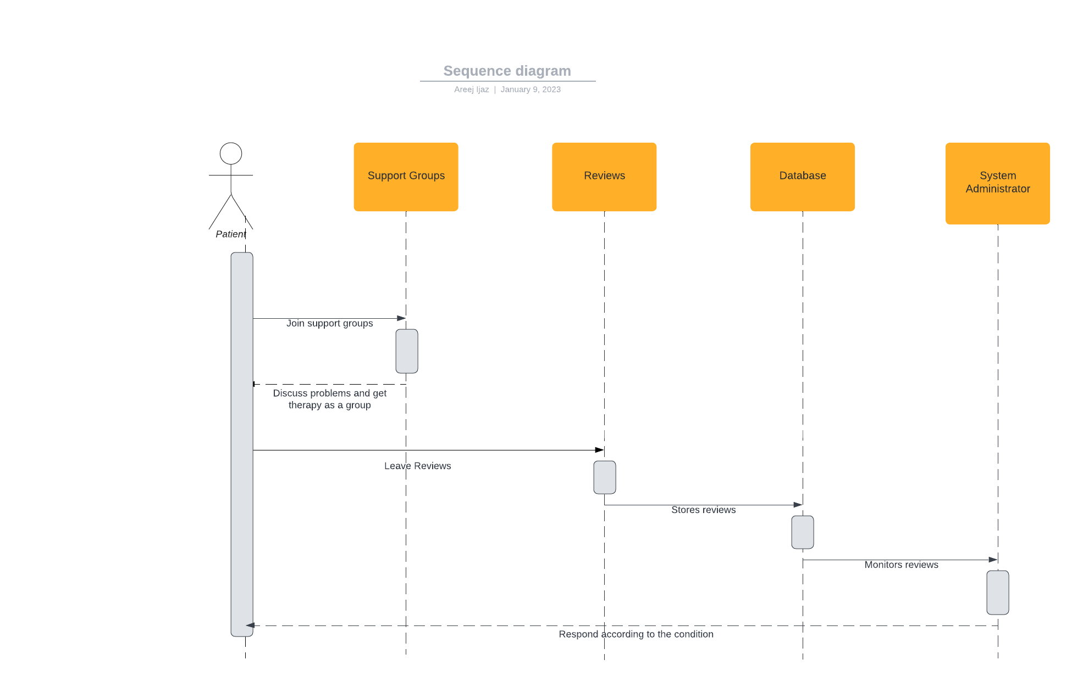

# The Entity Relation Diagram

The following entities are represented in the ERD.

**Patients:** This entity represents the patients that are registered on the web application.

**Doctors:** This entity represents the individual doctors and clinics registered on the web application and available to provide consultations to patients.

**Medicines:** This entity represents the medicines available for purchase on the web application's online pharmacy.

**Online Pharmacy:** This entity represents the online pharmacy feature of the web application.

**Orders:** This entity represents the orders placed by patients on the web application, including both purchases of medicines and consultations with doctors.

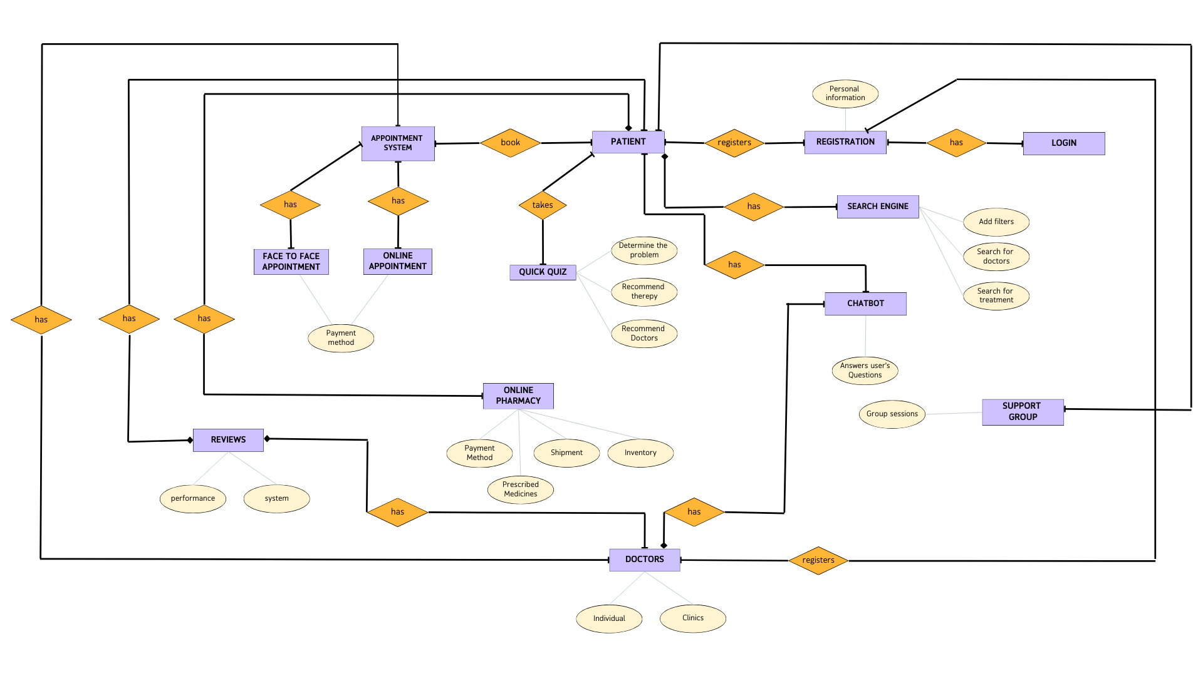

# The Data Flow Diagram

The Following DFD maps out the flow of information for any process or system.

